Akhanaton Museum Minia
متحف اخناتون المنيا

Minia City: Home City of the Conference
The Bride of Upper Egypt, The home city of Nefertiti, The Monalisa of Ancient Egypt, The seat of Akhenaton, Father of Monotheism, The route Jesus and his mother followed seeking safety.
The city is attractive and alluring throughout its history with an enduring treasure: the warm and the affectionate hearts of its people.

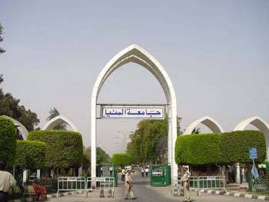

Minia University: Conference Institution
A leading educational institution in Upper Egypt with 16 faculties covering different specialization areas, very much interested in hosting educational dialog and in creating possible communication channels among nations.

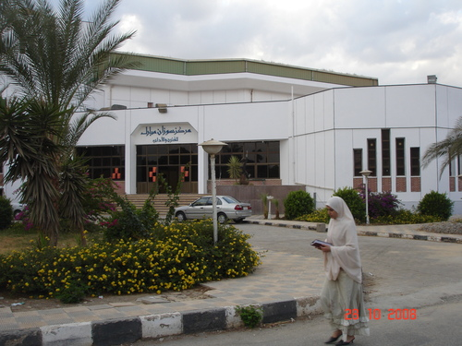

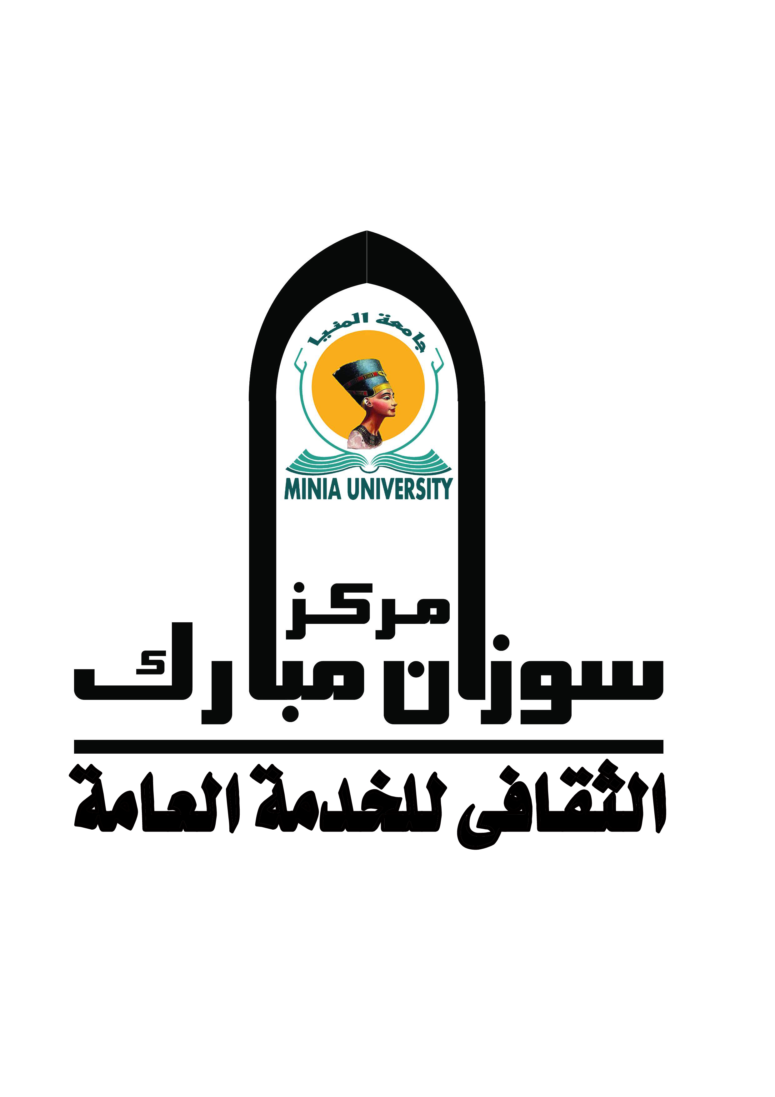
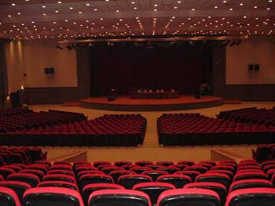

Suzan Mubarak Center: Conference Organizer
The Biggest of all Minia University Foundations; having a global, social and cultural vision and mission with nine working units committed to social service and cultural exchange.

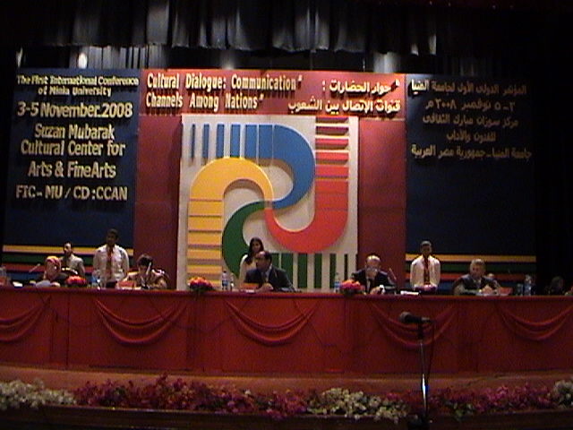

The First International Conference of The three- year series of Minia University: November 3rd, 2008.
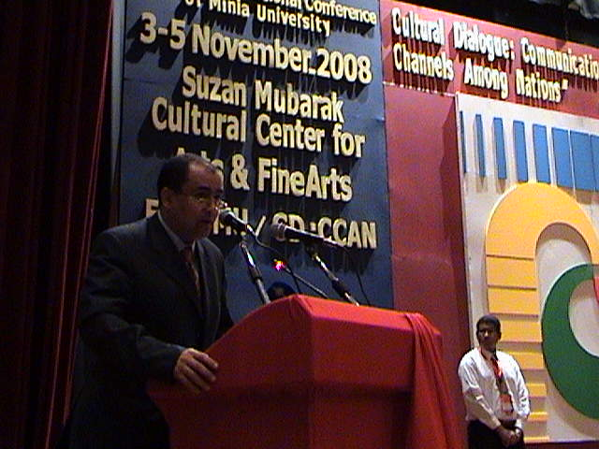

- Professor Maher Gaber Mohammed
President of Minia University and Head of the Suzan Mubarak Center Administrative Council.
Addressing Conference audience
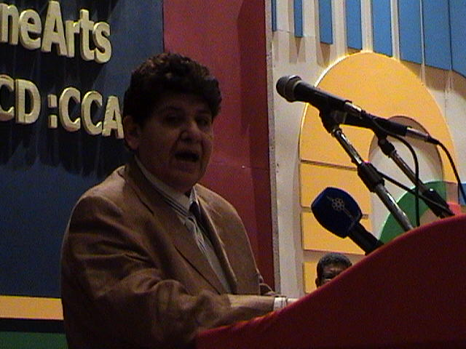

- Professor Sheika Rasha Al-Sabah
Vice-Minister of the Ministry of Higher Education, Kuwait
Addressing Conference audience
.
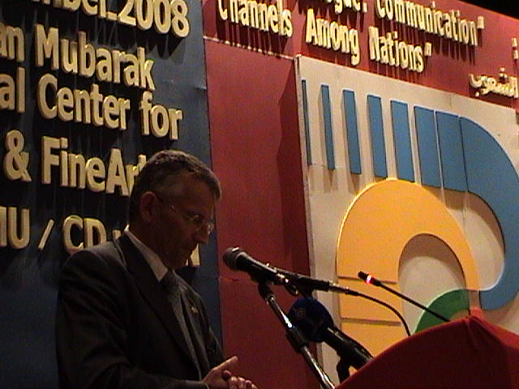

- H.E. Mr. Ferry Kerckhove
Ambassador of Canada to Egypt addressing conference audience.
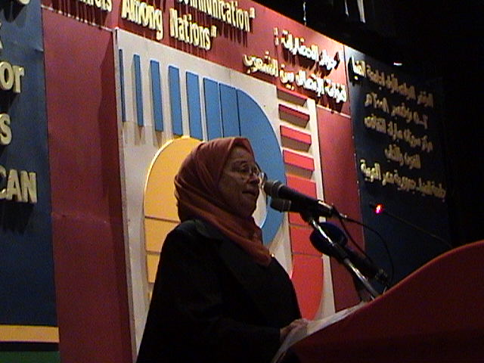

- Professor Amal Moustafa
Chairperson of The Conference and Vice Head of The Suzan Mubarak Center Administrative council.
Addressing Conference audience

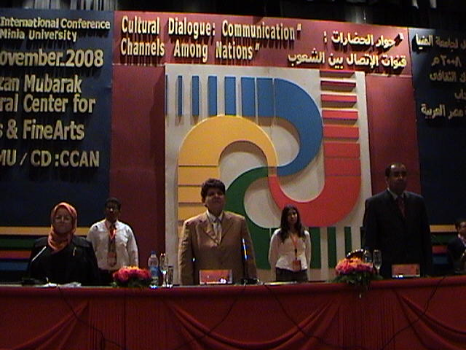

- Table -on- the Stage: Conference Opening Ceremony

- Professor Maher Gaber Mohammed
President of Minia University
- Professor Sheika Rasha Al-Sabah
Vice Minister of The Ministry of Higher Education, Kuwait.
- Professor Amal Moustafa
Chairperson of The Conference and Vice Head of The Suzan Mubarak Center Administrative council.

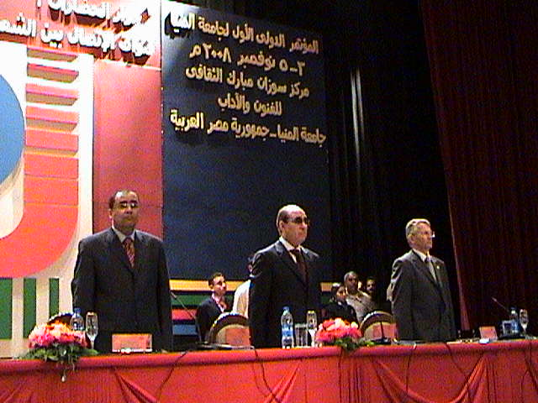

- Table -on- the Stage: Conference Opening Ceremony

- H.E. Mr. Ferry Kerckhove
Ambassador of Canada to Egypt.
- Major General Ahmed Diyaa Al-Din
Governor of Minia
- Professor Maher Gaber Mohammed
President of Minia University

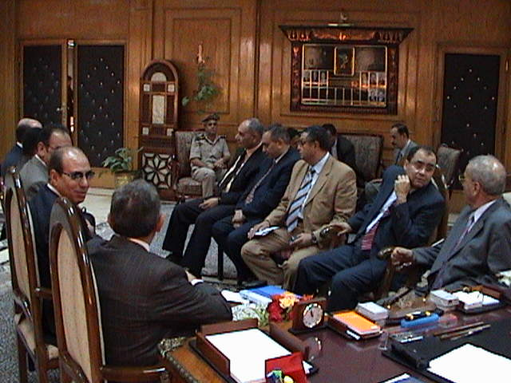

- Conference Guests at the Presidents’ Office before The Opening Ceremony.
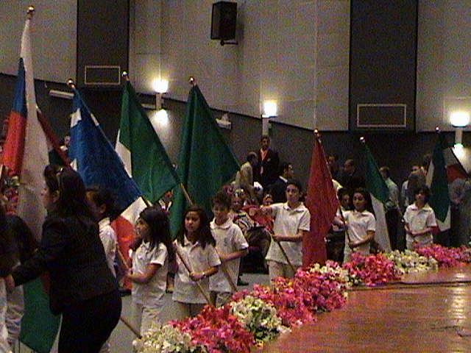

- Flag Parade by “Les Junior”, Conference Opening Ceremony.
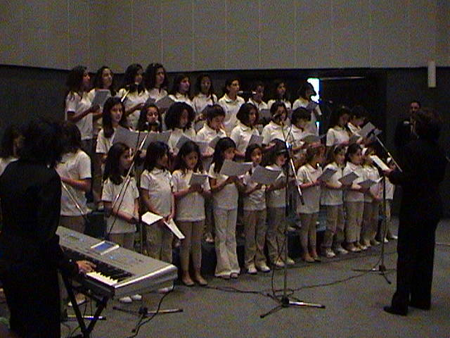

- Conference Song by “Les Junior”, Opening Ceremony.
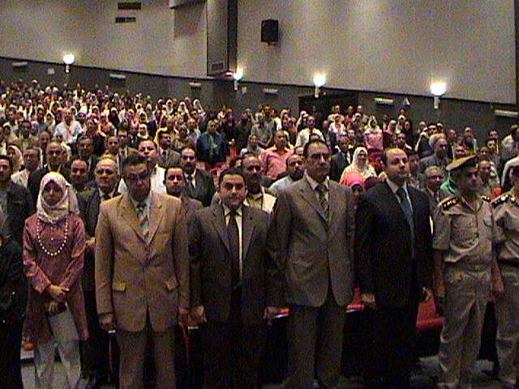
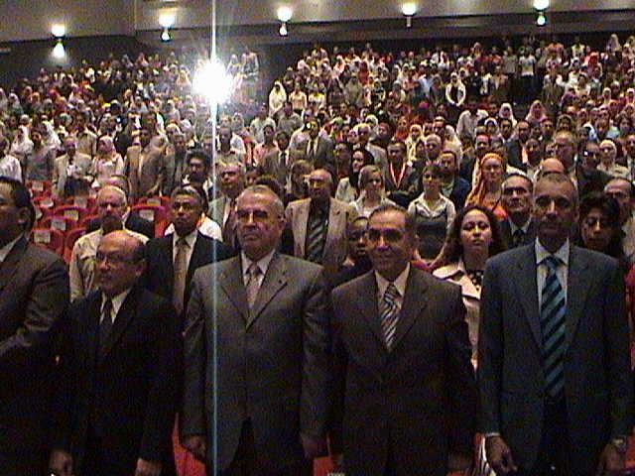

- Opening Ceremony: The National Anthem

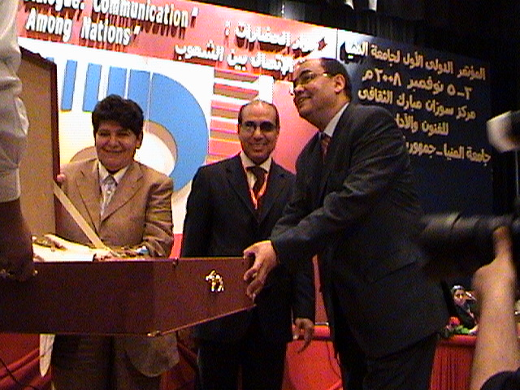
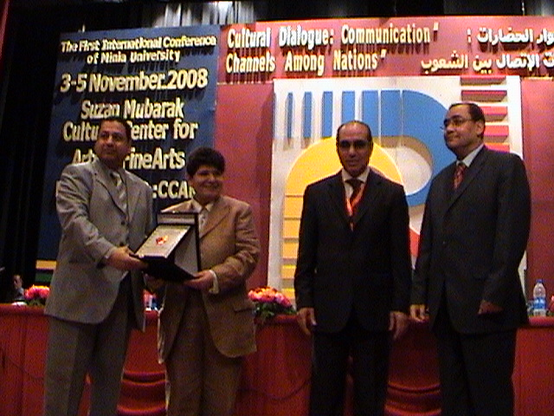
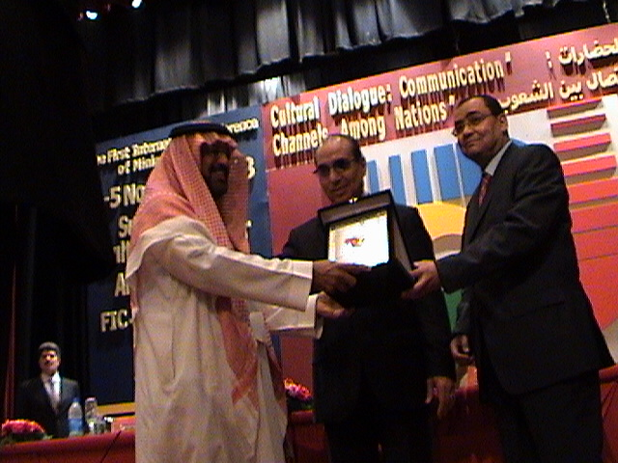

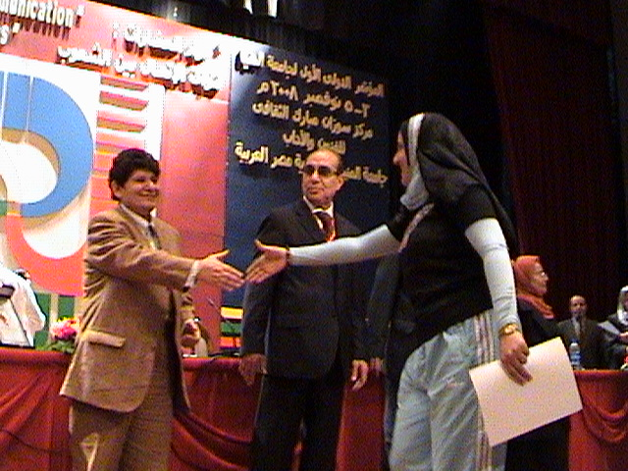

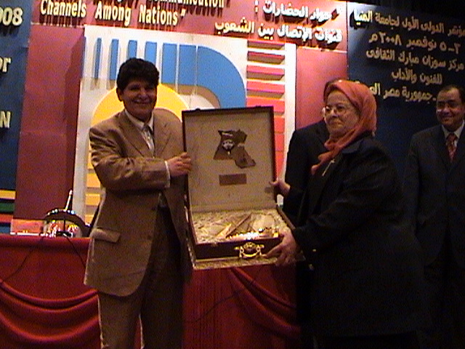

- Ceremony of Recognition

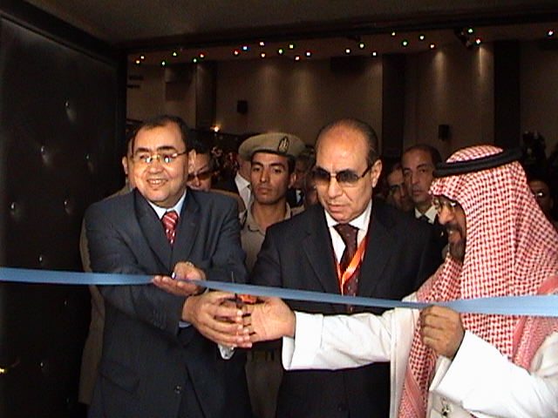

- The Inauguration of the Cultural Festival

From the right

- Mr. Oqeil; Saudi Cultural Counselor
- Major General Ahmed Diyaa Al-Din; Minia Governor
- Professor Maher Gaber; President of Minia University

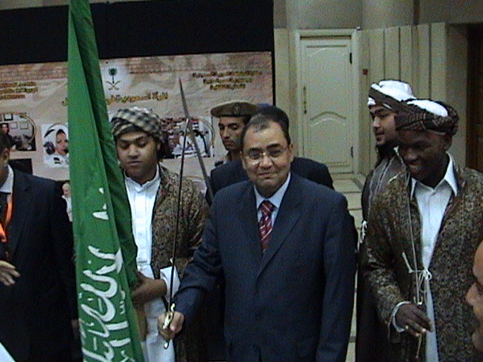
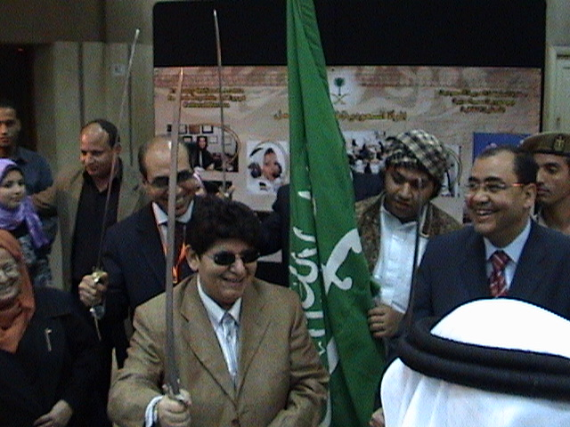

- The Saudi Booth in The Cultural Festival
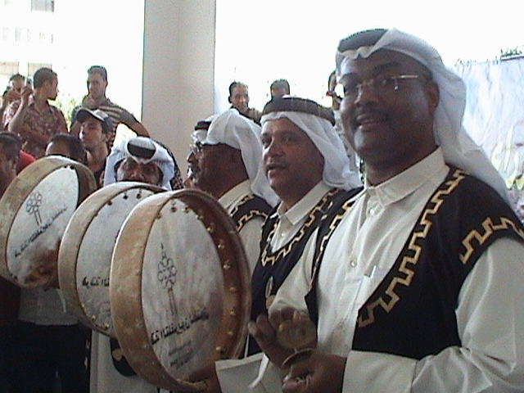
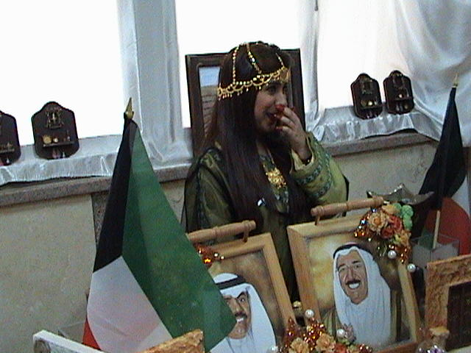

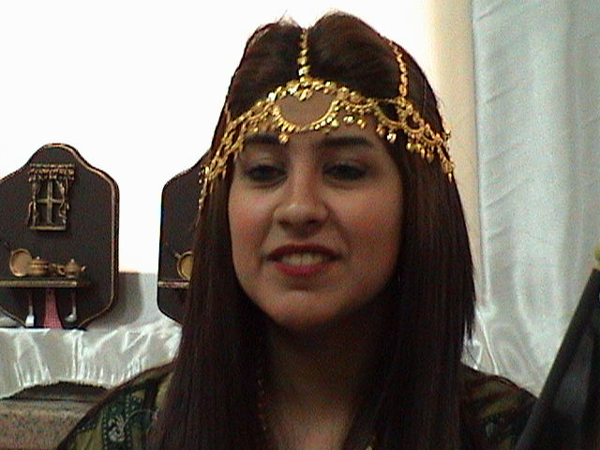

- Kuwaiti TV Folkloric Band in The Cultural Festival

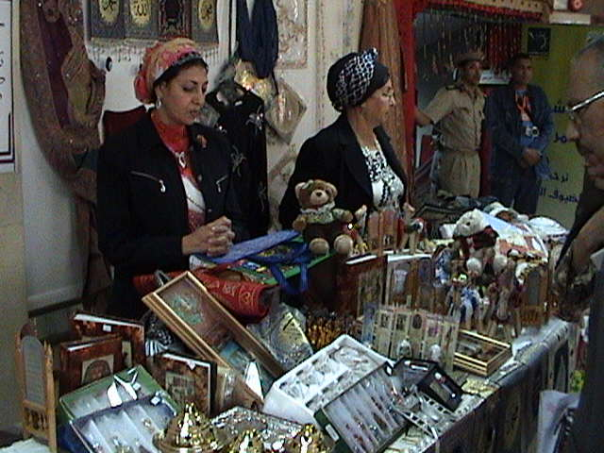
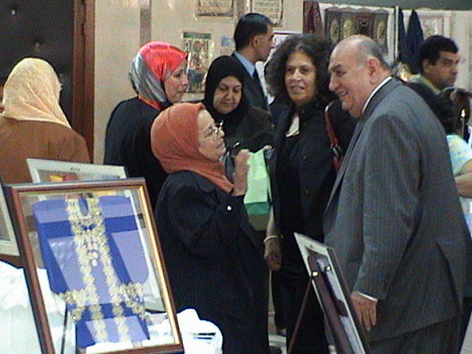

- The Kuwaiti booth in The Cultural Festival

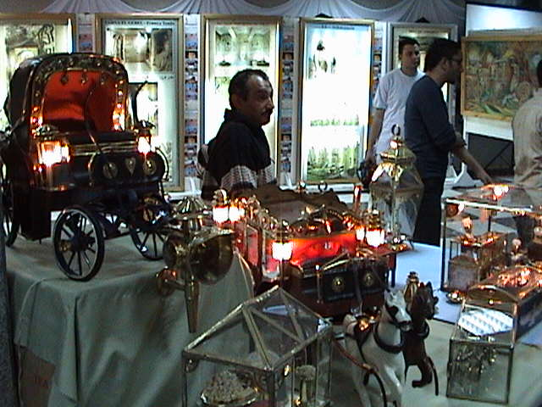
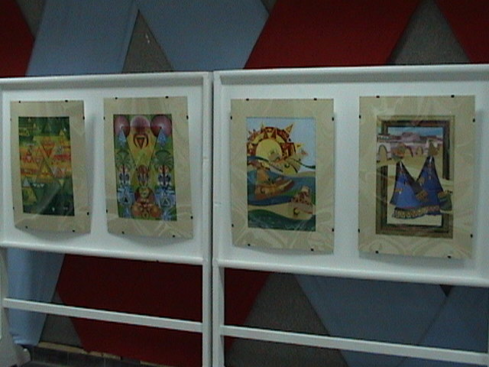

- The Booth of Minia Governorate

